Oakhurst Elementary News 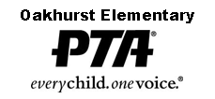 Kelly Kennedy, Principal Heidi Bockover, Asst. Principal Shannon Jackson, PTA President Editor:Debbie Sawa-Szsotak November, 2017 Volume 18, Issue 3
October Character Award Winner
Cooperation
Bianka Hay
Jose Rizo-Rivera
Caydence Jansen
Kennedy Rigali
Pierce Keich
Gwendolyn Keller
Malina Nunez
Hadley Namey
Isabella Peterson
Eliseo Agastra
Lucy Scholes
Ramsey Pahl
Sophia Barton
Levi Wood
Kayleigh Stidham
Ashlyn Dubrava
Arianna Petrulis
Wilber Olivet-Suchite
Levi Rands
Aiden Gonzalez
Tony Fisher
Everett Insixiengmey
Alisson Montes
Dylan Vinci
Kendall Brown
Xochitl Rios-Pena
Faith Miller
Waseem Shahin
Sebastian Laird
Roman Petruccelli
Amelia McDowell
Christina Hills
Cameron Sherwood
Madison Turner
Colin Maloney
Caitlin Shaw
Nevaeh Finn
Jackson Sullivan
Omari Searcy

Character Word for November
Citizenship

A note from our Principal, Kelly Kennedy

As we move into the month of November, it is time to give thanks. I am thankful for all the wonderful people that work so hard to make Oakhurst the wonderful school that it is. I see our PTA putting in so many hours, volunteers coming and going all day and our fabulous staff working so very hard. It truly takes a community, and we have the best community here at Oakhurst! Thank you for all you do!
Congratulations to Shelley Henrion for being nominated as Oakhurst Elementary’s Teacher of the Year! Mrs. Henrion is a wonderful teacher of art and deserves this honor! Congratulations also to Anna Hauser for being nominated Oakhurst Elementary’s Support Staff Employee of the Year. Mrs. Hauser is a valued ESE assistant in our autistic unit and deserves this recognition. Congratulations to both of these women!
Last week we celebrated our Principal List and Honor Roll recipients and our students with Perfect Attendance! I am so proud of these students. Thank you also to the parents that helped their students achieve these accomplishments. Here are the numbers! WOW!! I am one proud principal!
111 students in third through fifth grade earned Principal List!
143 students in third through fifth grade earned Honor Roll!
196 students in Pre-K through fifth grade earned Perfect Attendance!
Perfect Attendance is earned by students being here EVERY DAY from bell to bell with no tardies or early pick-ups and no absences. Over 26% of our Oakhurst students in Pre-K through fifth grade earned Perfect Attendance! I thank all the families that put such an importance on getting their children here every day ready to learn!
Research shows that:
• Missing 10 percent of the school year, or about 18 days, negatively affects a student’s academic performance. That’s just two days a month and that’s known as chronic absence.
• By 6th grade, chronic absence becomes a leading indicator that a student will drop out of high school.
• The academic impact of missing that much school is the same whether the absences are excused or unexcused.
Thank you also to all the parents that are helping their students with at-home iStation. Do you know what Tier your student is in iStation? Each month your child is tested on iStation and put in a Tier I, II or III. This determines how many minutes they need to complete each week from 30 minutes to 90. Please ask your child what Tier they are in and help them complete some of those minutes at home!
I hope you will join us this Tuesday evening, Nov. 7th, at 5 PM for our next SAC Meeting in the Media Center. All are welcome! We will be discussing our most current data for each grade level. Please join us!
I thank you for your continued support! I wish you and your family a very Happy Thanksgiving!

A note from our PTA President, Shannon Jackson
The holiday season is here already and we are having a phenomenal year so far! Grandparents Lunch Week, Walk to School Day, our General Meeting with Book BINGO, and our first Spirit Night at Astro Skate have kept us all busy and all were incredible events! Thank you to those that attended Astro Skate, you helped to raise $562 for the school! On top of all that, our Fall Fundraiser has come to an end and we are looking forward to sharing with you how much the school raised thanks to all your generosity.
I’d like to acknowledge the teachers that had 100% of their September SPIKE calendars turned in! Congratulations to Mrs. Annand, Mrs. Barber, Mrs. Fulle, Ms. Gonzales, Mrs. Ewald, Ms. Lundquist, Ms. King, Mrs. Smith/Mrs. Ragozine, Ms. Foley (PreK). Each of these classes earned 4 books for their classroom library!
It is that time of year to give thanks and I am grateful for the amazing volunteers that we have at Oakhurst. We would not be able to do the PTA programs we have here without your help. It is a perfect time to also thank our teachers for the time they take every day to help enrich our children. We have a lot to be thankful for at Oakhurst! We hope you ALL will join us on November 15th as “Oakhurst Gives Back” to our community. Be on the lookout for a flier coming home with more details. If you have any questions, concerns, ideas or thoughts regarding PTA, please feel free to reach out to me personally via email at thejackson5fl@gmail or (727) 408-0887.
Have a safe and wonderful Thanksgiving break!

Upcoming Events
November Events:
November 1st- Fifth Grade Celebration Planning Meeting 7 PM
November 6th-NEHS Meeting 2:45-3:45 PM
November 7th- SAC Meeting 5 PM Media Center
November 8th- NEHS Induction Ceremony 6 PM-Cafeteria
November 12th-Car Wash benefitting 5th Grade Celebration-11:00-2:00-Oakhurst Elementary
November 13th- ALL HANDS 10 AM-12 PM
November 13th- Chipotle Night-Ulmerton Rd
November 14th- Transportation Day
November 15th- Great American Teach-In
November 15th- Oakhurst Gives Back 6 PM
November 17th- All Pro Dads- 7:25 AM—Cafeteria
November 18-26-Thanksgiving Break

Looking Ahead:
December Events:
December 5th- Fifth Grade Celebration Planning Meeting 7 PM
December 11th- ALL HANDS 10 AM-12 PM
December 15th- All Pro Dads- 7:25 AM—Cafeteria
December 23-January 7- Winter Break
January 8, 2018 – Hurricane Make-Up Day

Need an Oakhurst t-shirt? Send in payment & order form (found in front office) or contact Jennifer Conlon @ jennylynn_k@yahoo.com for more information!

ALL PRO DADS
Come and join us for breakfast and bonding on Friday, November 17th at 7:25 AM in the cafeteria. This month's topic is Reading. Why is reading so important? When parents read with their kids, it helps them bond together, creating stronger relationships. Kids may not remember everything about their childhood, but they will remember if their parents took the time to read with them. Join us and let's start making memories!
We raised just under $1,600 for the school from the fall Box Top Challenge. The next challenge will start in January, so start saving now!
The class winners are:
1st Place-Mrs.Wilson: 843 box tops
2nd Place-Mrs. Fulle: 815 box tops
3rd Place- Mrs. Turner: 735 box tops
And the winners of the PTA Membership ice cream contest are:
1st Place--Mrs. Fulle – Kindergarten
2nd Place-- Ms. Gonzales – Kindergarten
3rd Place--Mrs. Nickse – 5th grade
3rd Place--Mrs. Kunish – 4th grade
3rd Place--Mrs. Frechette – Kindergarten

We had a 3 way tie this year for third place! Congratulations to all the students and teachers that enjoyed their ice cream at lunch on October 27th.
PTA cards were sent home last week, make sure to check your student’s binder for them!
We have reached our first goal of 352 registered PTA Members! Thank you so much to those who have joined this year. Your $5.00 goes a long way in helping with our amazing PTA events. However, it’s never too late to join the PTA – so if you haven’t had time yet - Join TODAY!
If you have any questions feel free to contact Denise Rohrs at rohrsd@gmail.com

Sign Up for legislative alerts regarding children and school issues at: https://www.votervoice.net/FLPTA/register

MEMBERSHIP UPDATE
BOX TOP CONTEST RESULTS
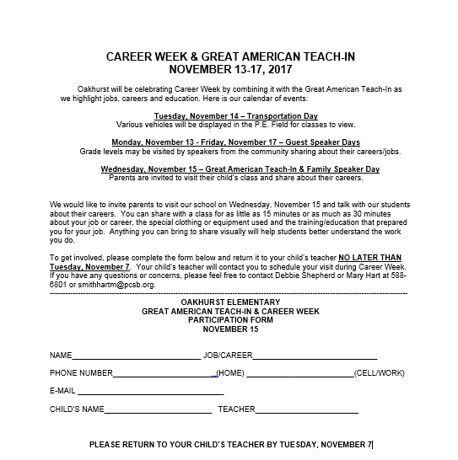
Clothing Closet
Occasionally a student may need a change of clothing due to an accident or spill. We can use the following for our closet:
- Boys shorts/pants—4T-14
- Girls shorts/pants—6-14
- Girls underwear—all sizes
- Boys underwear—8-14
We are good with tops!!!
If your child comes home with borrowed clothing, please wash and return for another child to use. Thank you!

Check out our website www.oakhurstpta.com

